Hickman Edge Systems May 2024
4 Commerce Way
Arden, North Carolina 28704
Phone 828-676-1700
Website HickmanEdgeSystems.com
Email info@hickmanedgesystems.com

Guide Specification
Specifier Notes: This guide specification is written in Construction Specifications Institute (CSI) 3-Part Format in accordance with The CSI Construction Specifications Practice Guide, MasterFormat, SectionFormat, and PageFormat.
This Section must be carefully reviewed and edited by the Architect to meet the requirements of the Project and local building code. Coordinate this Section with Conditions of the Contract, Division 01, other specification sections, and the Drawings. Delete all Specifier Notes after editing this Section.
Section numbers and titles are based on MasterFormat 2020 Edition.

07 71 13

MANUFACTURED COPINGS
Specifier Notes: This Section covers all Hickman Edge Systems coping systems. Consult Hickman Edge Systems for assistance in editing this Section as required for the Project.
Optional information is identified in blue font below. Select appropriate options and delete other information as needed. [delete this paragraph]
Consult Hickman Edge Systems for information regarding custom coping systems.
  - GENERAL
    - SECTION INCLUDES
A. Furnish and install premanufactured copings per the drawings and specifications, including all clips, sealant, fasteners, and joining to make weathertight and watertight. Components and accessories shall be factory-fabricated and supplied by a specified Manufacturer.

B. Contractor shall utilize Manufacturer's technical representative to perform field measuring, takeoff, shop drawing development and order processing for all coping components specified in this section.
    - RELATED REQUIREMENTS
Specifier Notes: Edit the following list of related sections as required for the Project. Limit the list to sections with specific information that the reader might expect to find in this Section but is specified elsewhere.
      - Section 07_______ – _______________ Roofing.
    - REFERENCE STANDARDS
Specifier Notes: List reference standards used elsewhere in this Section, complete with designations and titles. Delete reference standards from the following list not used in the edited Section.
      - FM Global (www.fmglobal.com).
      - SPRI (Single Ply Roofing Industry) (www.spri.org):
        - ANSI/SPRI/FM 4435/ES-1 – Wind Design Standard for Edge Systems Used with Low Slope Roofing Systems.
    - PREINSTALLATION MEETINGS
Specifier Notes: Edit the Preinstallation Meetings article as required for the Project. Delete this article if not required.
      - Convene preinstallation meeting [1 week] [2 weeks] before start of installation of coping system.
      - Require attendance of parties directly affecting Work of this Section, including Contractor, Architect, installer, and manufacturer’s representative.
      - Review the Following:
        - Materials.
        - Examination of roof edge areas.
        - Installation.
        - Cleaning.
        - Protection.
        - Coordination with other Work, including roofing installation.
    - SUBMITTALS
Specifier Notes: Edit the Submittals article as required for the Project. Delete submittals not required.
      - Comply with Division 01.
      - Products shall be manufactured in specified manufacturer’s facilities. Products fabricated by installer or other fabricator will not be acceptable unless fabricator can demonstrate to Architect’s satisfaction that products have been tested for resistance in accordance with Test Method RE-3 of ANSI/SPRI ES-1.
      - Product Data: Submit manufacturer’s product data, including installation instructions.
      - Shop Drawings: Submit manufacturer’s shop drawings, including plans, elevations, sections, and details, indicating dimensions, materials, components, fasteners, finish, and accessories.
      - Samples: Submit manufacturer’s sample of coping system.
        - Sample Size: Minimum 5.5” long.
      - Color Samples: Submit manufacturer’s color samples of coping cap, consisting of complete set of metal color chips representing manufacturer’s full range of available colors.
      - Manufacturer’s Certification: Submit manufacturer’s certification that materials comply with specified requirements and are suitable for intended application.
      - Manufacturer’s Project References: Submit manufacturer’s list of 10 successfully completed coping system projects of similar size and scope to this Project, including project name and location, name of architect, and type and quantity of coping systems furnished.
      - Warranty Documentation: Submit manufacturer’s standard warranty.
    - QUALITY ASSURANCE
      - Manufacturer’s Qualifications: Manufacturer regularly engaged in the manufacturing of coping systems of similar type to that specified for a minimum of 5 years.
      - Installer's Qualifications:
        - Installer regularly engaged in installation of coping systems of similar type to that specified for a minimum of 5 years.
        - Use persons trained for installation of coping systems.
    - DELIVERY, STORAGE, AND HANDLING
      - Delivery Requirements: Deliver materials to site in manufacturer’s original, unopened containers and packaging, with labels clearly identifying product name and manufacturer.
      - Storage and Handling Requirements:
        - Store and handle materials in accordance with manufacturer’s instructions.
        - Keep materials in manufacturer’s original, unopened containers and packaging until installation.
        - Store materials in clean, dry area indoors.
        - Do not store materials directly on floor or ground.
        - Protect materials and finish during storage, handling, and installation to prevent damage.
    - WARRANTY
Specifier Notes: Edit warranty requirements, see Product Specifier Notes for available warranty, Delete warranties NOT available.
      - Wind Warranty Period: Warranted in wind conditions up to 215 mph with a Lifetime wind warranty. Warranty specified for individual products below.
      - Wind Warranty Period: Warranted in wind conditions up to 120 mph with a 20 Year wind warranty. Warranty specified for individual products below.
      - Wind Warranty Period: Warranted in wind conditions up to 90 mph with a 10 Year wind warranty. Warranty specified for individual products below.
      - Warranty Period, Product: 5-year workmanship warranty covering replacement or repair of products that are defective in material or workmanship.
      - Warranty Period, Finish: Limited 30-year warranty for prefinished coil-coated steel and aluminum coated with Kynar 500 standard colors covering fade, chalk, and film integrity.
  - PRODUCTS
    - MANUFACTURERS
      - Manufacturer: Hickman Edge Systems, 4 Commerce Way, Arden, North Carolina 28704. Phone 828-676-1700. www.Hickmanedgesystems.com. info@Hickmanroofing.com.
Specifier Notes: Specify if substitutions will be permitted.
      - Substitutions: [Not permitted] [Comply with Division 01].
      - Single Source: Furnish materials from single manufacturer.
    - COPING SYSTEM
Specifier Notes: Specify coping system required for the Project. Delete coping systems not required.

Specifier Notes: Use the following to specify “PermaSnap Premier Plus” coping system.

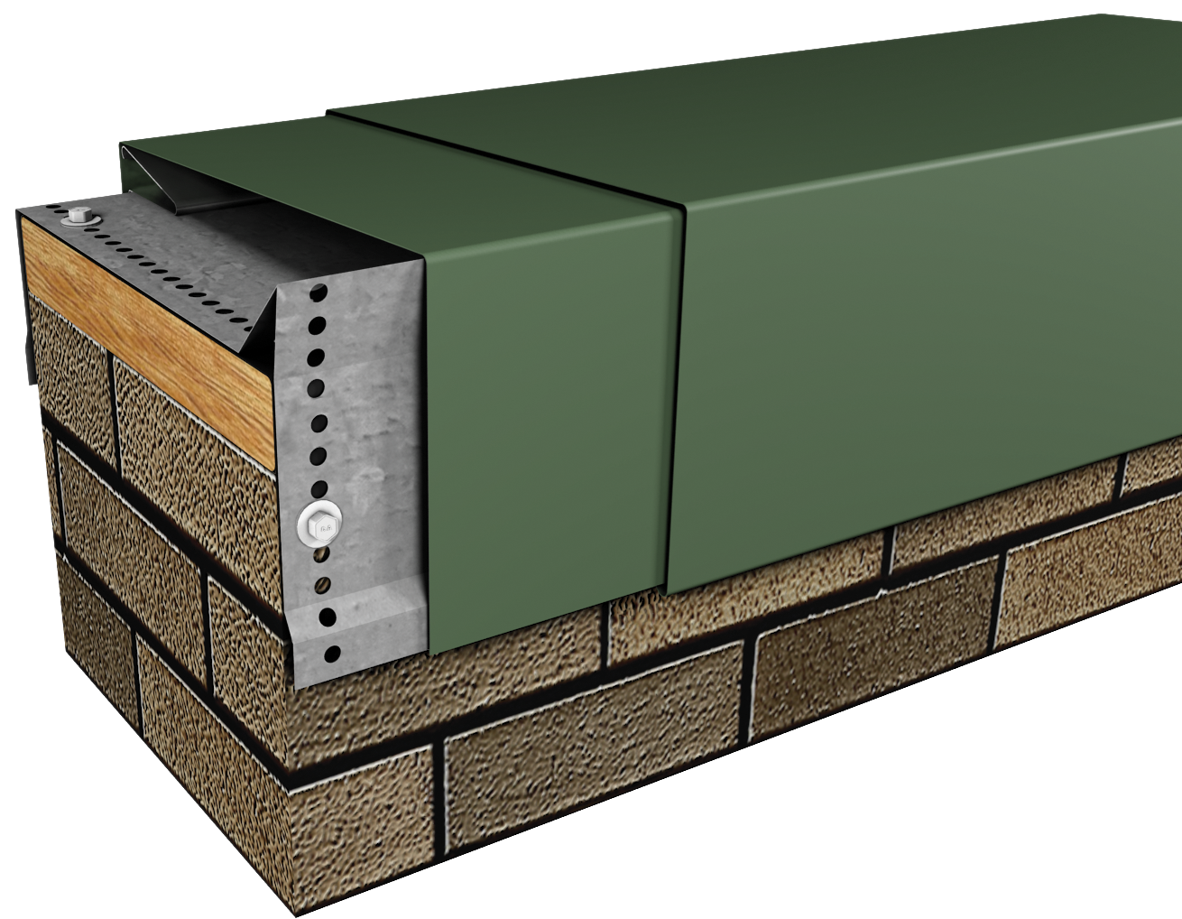

Hickman Edge Systems Website

Wind Warranty: Lifetime, 215 MPH

Wall width: MIN 3.5"/ MAX 39.875” (TESTED Up to 32”)
Outside face: MIN 3.5"/ MAX 12” (TESTED Up to 12”)
Inside face: MIN 2.75"/ MAX 12” (TESTED Up to 4”)

      - Coping System: “PermaSnap Premier Plus”.

        - Description:
          - Snap-on coping with intermittent clips for capping parapet walls.
          - Does not require exposed fasteners or joint sealants.
        - Performance Characteristics:
          - Snap-on Coping Cap Sections: Capable of expanding and contracting freely, statically engaged onto mechanically secured clips.
          - Snap-on Coping Cap Joints: Underlayed with concealed splices.
        - Approvals
          - ANSI/SPRI/FM 4435 ES-1 for 24 ga./.040” - 383 psf Vertical and 221 psf Horizontal, for 22 ga./.050”/.063” - 513 psf Vertical and 297 psf Horizontal.
          - FM Approved with 24 ga./.040” cover - 1-225 Perimeter and 1-150 Corner, with 22 ga./.050”/.063” cover - 1-300 Perimeter and 1-195 Corner.
          - Florida Product Approval.
          - Miami-Dade County Approved.
        - Intermittent Clips:
          - Material: 16 ga. galvanized steel.
          - Width: 12”
          - Fastener Holes: Pre-Punched.
        - Concealed Splices:
          - Material: Same as snap-on coping cap.
          - Finish and Color: Same as snap-on coping cap.
          - Width: 8”
          - Sealant Strips: Factory-applied dual non-curing isocryl butyl sealant strips.

Specifier Notes: Use the following to specify “PermaSnap Premier” coping system.
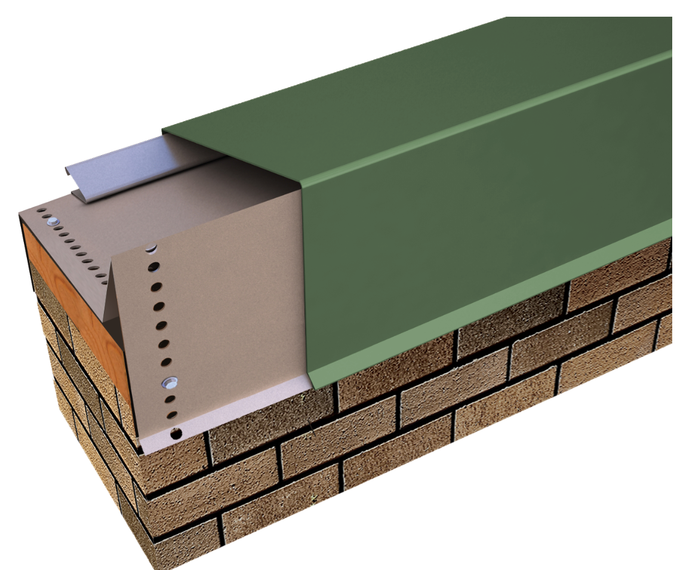

Hickman Edge Systems Website

Wind Warranty: 20-Year, 120 MPH

Wall width: MIN 3.5"/ MAX 39.875” (TESTED Up to 16”)
Outside face: MIN 3"/ MAX 12” (TESTED Up to 6”)
Inside face: MIN 2.25"/ MAX 12” (TESTED Up to 4”)

      - Coping System: “PermaSnap Premier”.
        - Description:
          - Snap-on coping with intermittent clips for capping parapet walls.
          - Does not require exposed fasteners or joint sealants.
        - Performance Characteristics:
          - Snap-on Coping Cap Sections: Capable of expanding and contracting freely, statically engaged onto mechanically secured clips.
          - Snap-on Coping Cap Joints: Underlayed with concealed splices.
        - Approvals
          - ANSI/SPRI/FM 4435 ES-1 for 24 ga./.040” - 283 psf Vertical and 164 psf Horizontal, for 22 ga./.050”/.063” - 391 psf Vertical and 226 psf Horizontal.
          - FM Approved with 24 ga./.040” cover - 1-165 Perimeter and 1-105 Corner, with 22 ga./.050”/.063” cover - 1-225 Perimeter and 1-150 Corner.
          - Florida Product Approval.
          - Miami-Dade County Approved.
        - Intermittent Clips:
          - Material: 20 ga. galvanized steel.
          - Width: 12”
          - Fastener Holes: Pre-Punched.
        - Concealed Splices:
          - Material: Same as snap-on coping cap.
          - Finish and Color: Same as snap-on coping cap.
          - Width: 8”
          - Sealant Strips: Factory-applied dual non-curing isocryl butyl sealant strips.

Specifier Notes: Use the following to specify “PermaSnap Continuous Cleat” coping system.
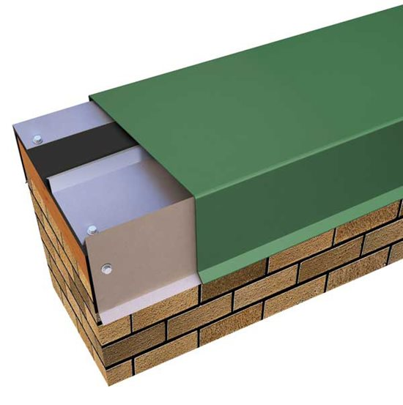
Hickman Edge Systems Website

Wind Warranty: 20-Year, 120 MPH

Wall width: MIN 3.75"/ MAX 40“ (TESTED Up to 24”)
Outside face: MIN 3"/ MAX 12” (TESTED Up to 12”)
Inside face: MIN 2"/ MAX 12” (TESTED Up to 4”)

      - Coping System: “PermaSnap Continuous Cleat”.
        - Description:
          - Coping with continuous outside and inside cleats for capping parapet walls.
          - Does not require exposed fasteners or joint sealants.
        - Performance Characteristics:
          - Coping Cap Cover: Inside face crimped to continuous cleat per installation instructions.
          - Coping Cap Joints: Underlayed with concealed splices.
        - Approvals
          - ANSI/SPRI/FM 4435 ES-1 for 24 ga./.040” - 422 psf Vertical and 244 psf Horizontal, for 22 ga./.050”/.063” - 513 psf Vertical and 297 psf Horizontal.
          - FM Approved with 24 ga./.040” cover - 1-180 Perimeter and 1-120 Corner, with 22 ga./.050”/.063” cover - 1-240 Perimeter and 1-165 Corner.
          - Florida Product Approval.
          - Miami-Dade County Approved.
        - Continuous Cleats:
          - Material: 20 ga. galvanized steel (One on front; One on Back)
          - Width: 12’-0”
          - Fastener Holes: Pre-Punched.
        - Concealed Splices:
          - Material: Same as coping cap.
          - Finish and Color: Same as coping cap.
          - Width: 8”
          - Sealant Strips: Factory-applied dual non-curing isocryl butyl sealant strips.

Specifier Notes: Use the following to specify “PermaSnap” coping system.

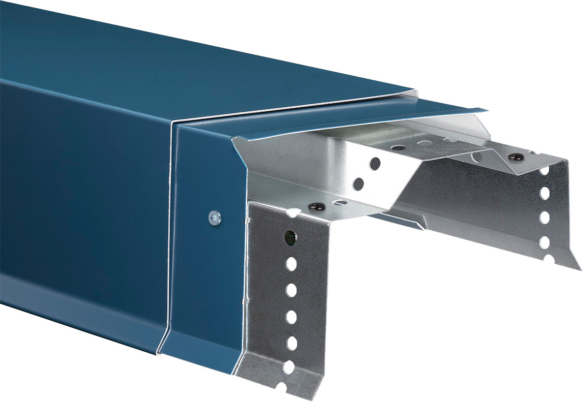
Hickman Edge Systems Website
Wind Warranty: 20-Year, 120 MPH

Wall width: MIN 6"/ MAX 24“ (TESTED Up to 16”)
Outside face: MIN 3.25"/ MAX 10" with 24ga./.040" cover and 12” with 22ga./.050"/.063" cover (TESTED Up to 6”)
Inside face: MIN 3"/ MAX 6” (TESTED Up to 4”)

      - Coping System: “PermaSnap”.
        - Description:
          - Snap-on coping with intermittent clips for capping parapet walls.
          - Does not require exposed fasteners or joint sealants.
        - Performance Characteristics:
          - Snap-on Coping Cap Sections: Capable of expanding and contracting freely, statically engaged onto mechanically secured clips.
          - Snap-on Coping Cap Joints: Underlayed with concealed splices capable of draining water.
        - Approvals
          - ANSI/SPRI/FM 4435 ES-1 up to 121 psf Vertical and 69 psf Horizontal.
        - Anchor Clips:
          - Material: 20 ga. galvanized steel.
          - Width: 12”
          - Fastener Holes: Pre-Punched.
        - Concealed Splices:
          - Material: Same as snap-on coping cap.
          - Finish and Color: Same as snap-on coping cap.
          - Width: 6”
          - Integral gutter to channel water back to roof.

Specifier Notes: Use the following to specify “PermaSnap Plus” coping system.
Hickman Edge Systems Website

Wind Warranty: 20-Year, 120 MPH

Wall width: MIN 6"/ MAX 32“ (TESTED Up to 24”)
Outside face: MIN 3.25"/ MAX 10" with 24ga./.040" cover and 12” with 22ga./.050"/.063" cover (TESTED Up to 6”)
Inside face: MIN 3"/ MAX 6” (TESTED Up to 4”)

      - Coping System: “PermaSnap Plus”.
        - Description:
          - Snap-on coping with intermittent clips for capping parapet walls.
          - Does not require exposed fasteners or joint sealants.
        - Performance Characteristics:
          - Snap-on Coping Cap Sections: Capable of expanding and contracting freely, statically engaged onto mechanically secured clips.
          - Snap-on Coping Cap Joints: Underlayed with concealed splices capable of draining water.
        - Approvals
          - ANSI/SPRI/FM 4435 ES-1 up to 156 psf Vertical and 90 psf Horizontal.
        - Anchor Clips:
          - Material: 16 ga. galvanized steel.
          - Width: 12”
          - Fastener Holes: Pre-Punched.
        - Concealed Splices:
          - Material: Same as snap-on coping cap.
          - Finish and Color: Same as snap-on coping cap.
          - Width: 6”
          - Integral gutter to channel water back to roof.

Specifier Notes: Use the following to specify “Roofer’s Edge” coping system.
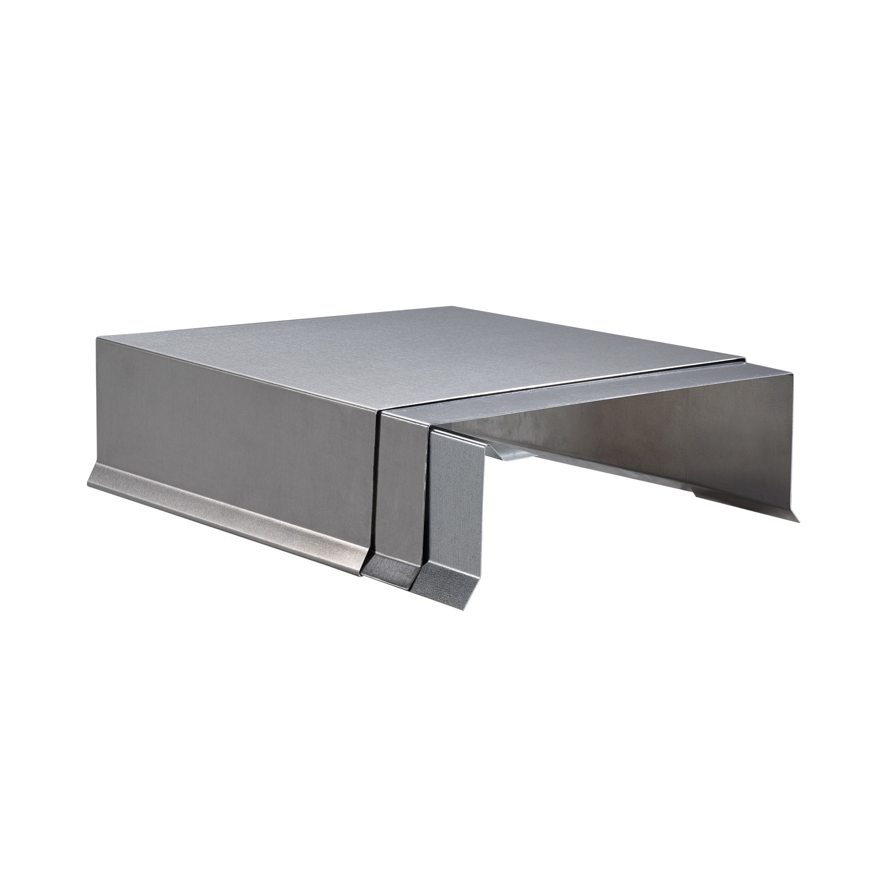
Hickman Edge Systems Website

Wind Warranty: 10-Year, 90 MPH

Wall width: MIN 4"/ MAX 12“ (TESTED Up to 12”)
Outside face: MIN 3"/ MAX 6” (TESTED Up to 6”)
Inside face: MIN 2"/ MAX 6” (TESTED Up to 6”)

      - Coping System: “Roofer’s Edge”.
        - Description:
          - Coping with continuous outside cleat for capping parapet walls with exposed fastener on inside face.
        - Performance Characteristics:
          - Coping Cap Joints: Underlayed with concealed splices.
        - Approvals
          - ANSI/SPRI/FM 4435 ES-1 up to 103 psf Vertical and 61 psf Horizontal.
        - Continuous Cleat:
          - Material: 22 ga. galvanized steel.
          - Width: 12’-0”
        - Concealed Splices:
          - Material: Same as coping cap.
          - Finish and Color: Same as coping cap.
          - Width: 4”

Specifier Notes: Use the following to specify “PermaSnap Single Cantilever” coping system.
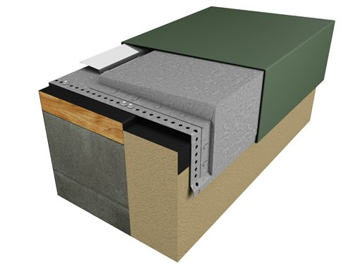

Hickman Edge Systems Website

Wind Warranty: 20-Year, 120 MPH

Wall width: MIN 8"/ MAX 32" (TESTED Up to 24”)
Outside face: MIN 3.5"/ MAX 12” (TESTED Up to 10”)
Inside face: MIN 2.75"/ MAX 6” (TESTED Up to 4”)
Cantilever distance over EIFS/Panel: MIN 1"/ MAX 10" (TESTED up to 4”)

      - Coping System: “PermaSnap Single Cantilever”.
        - Description:
          - Snap-on coping with intermittent clips for capping parapet walls with EFIS, brick or panel on wall.
          - Does not require exposed fasteners or joint sealants.
        - Performance Characteristics:
          - Snap-on Coping Cap Sections: Capable of expanding and contracting freely, statically engaged onto mechanically secured clips.
          - Snap-on Coping Cap Joints: Underlayed with concealed splices.
        - Approvals
          - ANSI/SPRI/FM 4435 ES-1 up to 221 psf Vertical and 128 psf Horizontal.
          - FM Approved Up to 1-120 Perimeter and 1-75 Corner.
          - Florida Product Approval.
          - Miami-Dade County Approved.
        - Intermittent Clips:
          - Material:
            - Base: 16 ga. galvanized steel.
            - Riser: 20 ga. galvanized steel.
          - Width: 12”
          - Fastener Holes: Pre-Punched.
        - Concealed Splices:
          - Material: Same as snap-on coping cap.
          - Finish and Color: Same as snap-on coping cap.
          - Width: 8”
          - Sealant Strips: Factory-applied dual non-curing isocryl butyl sealant strips.

Specifier Notes: Use the following to specify “PermaSnap Cantilever (Saddle Version)” coping system.
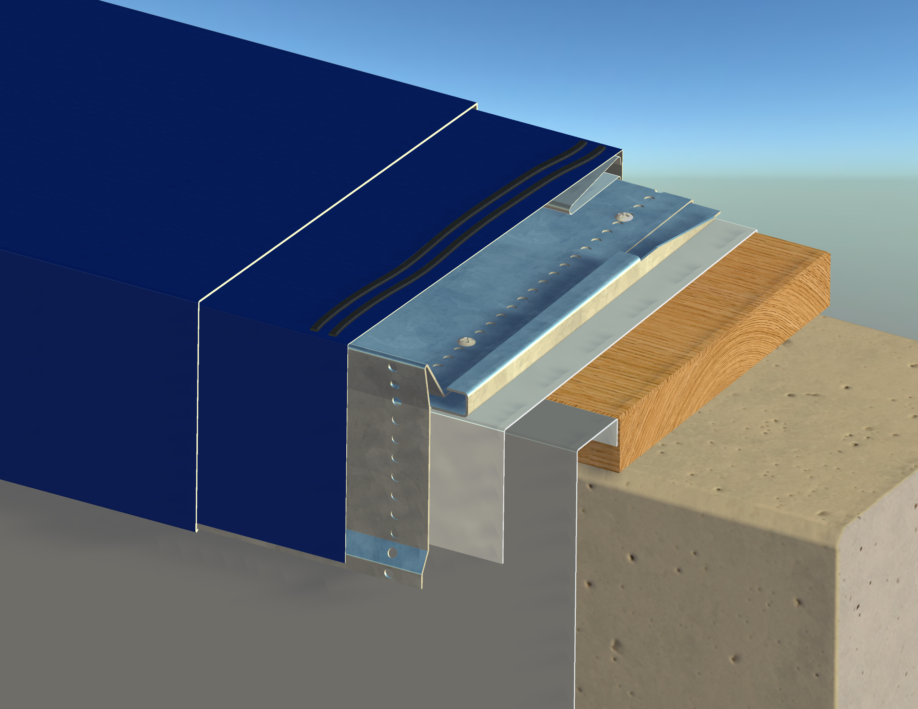

Hickman Edge Systems Website

Wind Warranty: 20-Year, 120 MPH

Wall width: MIN 3.5"/ MAX 32" (TESTED Up to 24”)
Outside face: MIN 3.5"/ MAX 12” (TESTED Up to 10”)
Inside face: MIN 2.75"/ MAX 12” (TESTED Up to 4”)
Cantilever distance over EIFS/Panel: MIN 1"/ MAX 10"

      - Coping System: “PermaSnap Cantilever (Saddle Version)”.
        - Description:
          - Snap-on coping with intermittent clips for capping parapet walls with EFIS, brick or panel on wall.
          - Does not require exposed fasteners or joint sealants.
        - Performance Characteristics:
          - Snap-on Coping Cap Sections: Capable of expanding and contracting freely, statically engaged onto mechanically secured clips.
          - Snap-on Coping Cap Joints: Underlayed with concealed splices.
        - Approvals
          - ANSI/SPRI/FM 4435 ES-1 up to 221 psf Vertical and 128 psf Horizontal.
          - FM Approved Up to 1-120 Perimeter and 1-75 Corner.
          - Florida Product Approval.
          - Miami-Dade County Approved.
        - Intermittent Clips:
          - Material:
            - Base: 16 ga. galvanized steel.
            - Riser: 20 ga. galvanized steel.
          - Width: 12”
          - Fastener Holes: Pre-Punched.
        - Concealed Splices:
          - Material: Same as snap-on coping cap.
          - Finish and Color: Same as snap-on coping cap.
          - Width: 8”
          - Sealant Strips: Factory-applied dual non-curing isocryl butyl sealant strips.

Specifier Notes: Use the following to specify “PermaSnap Dual Cantilever” coping system.

Hickman Edge Systems Website

Wind Warranty: 20-Year, 120 MPH

Wall width: MIN 8"/ MAX with 24ga./.040" cover is 24” with 22ga./.050"/.063" cover is 32"
Outside face: MIN 3.5"/ MAX 12”
Inside face: MIN 3.5"/ MAX 12”
Cantilever distance over EIFS/Panel (Front and Back): MIN 1"/ MAX 6"

      - Coping System: “PermaSnap Dual Cantilever”.
        - Description:
          - Snap-on coping with intermittent clips for capping parapet walls with EFIS, brick or panel on both sides of the wall.
          - Does not require exposed fasteners or joint sealants.
        - Performance Characteristics:
          - Snap-on Coping Cap Sections: Capable of expanding and contracting freely, statically engaged onto mechanically secured clips.
          - Snap-on Coping Cap Joints: Underlayed with concealed splices.
        - Intermittent Clips:
          - Material:
            - Base: 16 ga. galvanized steel.
            - Riser: 20 ga. galvanized steel.
          - Width: 12”
          - Fastener Holes: Pre-Punched.
        - Concealed Splices:
          - Material: Same as snap-on coping cap.
          - Finish and Color: Same as snap-on coping cap.
          - Width: 8”
          - Sealant Strips: Factory-applied dual non-curing isocryl butyl sealant strips
Specifier Notes: Use the following to specify “PermaSnap Double Sloped” coping system.
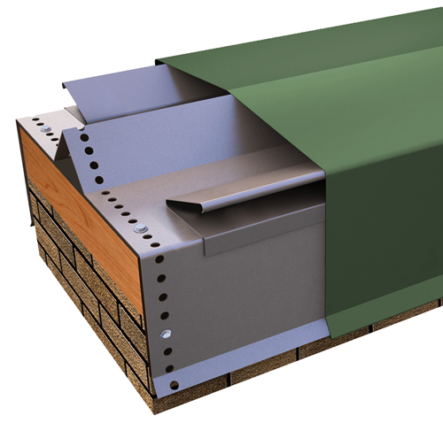
Hickman Edge Systems Website

Wind Warranty: 20-Year, 120 MPH
Wall width: MIN 6"/ MAX with 24ga./.040" cover is is 24” with 22ga./.050"/.063" cover is 32"
Outside face: MIN 2.25"/ MAX 12”
Inside face: MIN 2.25"/ MAX 12”

      - Coping System: “PermaSnap Double Sloped”.
        - Description:
          - Snap-on coping with intermittent clips for capping parapet walls.
          - Does not require exposed fasteners or joint sealants.
        - Performance Characteristics:
          - Snap-on Coping Cap Sections: Capable of expanding and contracting freely, statically engaged onto mechanically secured clips.
          - Snap-on Coping Cap Joints: Underlayed with concealed splices.
        - Intermittent Clips:
          - Material: 20 ga. galvanized steel.
          - Width: 12”
          - Fastener Holes: Pre-Punched.
        - Concealed Splices:
          - Material: Same as snap-on coping cap.
          - Finish and Color: Same as snap-on coping cap.
          - Width: 8”
          - Sealant Strips: Factory-applied dual non-curing isocryl butyl sealant strips.

Specifier Notes: Specify coping cap material. Delete materials not required.
          - Material: [0.040” aluminum] [0.050” aluminum] [0.063” aluminum] [24 ga. galvanized steel] [22 ga. galvanized steel]
          - Formed Lengths: 12’-0”.
Specifier Notes: Specify coping cap finish. Delete finishes not required. Consult Hickman Edge Systems for finish selection for each material.
          - Finish: [Mill] [Prefinished Kynar] [Premium prefinished Kynar] [Post-finished Kynar] [Prefinished anodized] [post-finished anodized].
Specifier Notes: Specify coping cap color. Consult Hickman Edge Systems for standard, premium, and custom colors for each finish.
          - Color: ____________.

        - Wall width, outside face dimension and inside face dimension as indicated on the Drawings.
        - Fasteners:
          - Suitable for intended substrate.
          - Provided by coping system manufacturer.
        - Factory-Fabricated Accessories:
Specifier Notes: Specify factory-fabricated accessories as required for the Project.
Specify Welded or Metal-Lok fabrication of accessories. For welded, must use .050” aluminum or thicker.
Delete accessories not required. Consult Hickman Edge Systems for accessory details.
          - Fabrication: Factory-Fabricated [Welded] [Metal-Lok].
          - Material, Finish, and Color: Same as coping cap.
Specifier Notes: Edit the list of accessories as required for the Project.
          - Miters:
- Outside.
- Inside.
- Transition.
- T-miter.
- Z-miter.
- Ridge.
- Valley.
          - End Caps:
                - Left.
                - Right.
          - End Terms:
            - Left.
            - Right.
          - Radius:
            - Welded:
              - To straight miter.
              - End cap.
            - Metal-Lok:
              - To straight miter.
              - End cap.
  - EXECUTION
    - EXAMINATION
      - Examine roof edge areas, including roofing and blocking, to receive coping system.
      - Verify surfaces to support coping system are clean, dry, flat, level from front to back, secure, and of proper dimensions.
      - Notify Architect, Owner’s representative, and roofing installer of conditions that would adversely affect installation.
      - Do not begin installation until unacceptable conditions are corrected.
    - INSTALLATION
      - Install coping system in accordance with manufacturer’s instructions at locations indicated on the Drawings.
Specifier Notes: Provide the section number for the specified roofing.
      - Roofing: Specified in Section 07_______.
      - Shim areas of walls not level from front to back.
      - Fasteners: Install coping system using concealed fasteners in accordance with manufacturer’s instructions.
      - Install concealed splices at all clip locations.
      - Thermal Movement: Leave 1/4” gap between coping cap sections to allow for thermal expansion and contraction.
      - Do not use sealant at splices.
      - Review lengths of straight pieces of coping cap before cutting to avoid creating relatively short sections adjacent to full-length sections.
      - Isolate coping system from ACQ treated wood blocking or other galvanically incompatible material with appropriate material.
    - CLEANING
      - Clean coping system promptly after installation in accordance with manufacturer’s instructions.
      - Remove clear protective vinyl film.
      - Do not use harsh cleaning materials or methods that could damage finish.
    - PROTECTION
      - Protect installed coping system to ensure that, except for normal weathering, coping system will be without damage or deterioration at time of Substantial Completion.

END OF SECTION

